Title of the Project

Submitted in partial fulfillment of the requirements for the degree of

Master of Science
In
Data Science

by

Name of the Student

Registration Number

Under the guidance of

Dr. XXXXXXXX
School of Advanced Sciences
VIT - Vellore



November, 2025

DECLARATION

I hereby declare that the thesis entitled "Title of the Project " submitted by me, for the award of the degree of Master of Science in Data Science to VIT is a record of bonafide work carried out by me under the supervision of Name of the Guide.

I further declare that the work reported in this thesis has not been submitted and will not be submitted, either in part or in full, for the award of any other degree or diploma in this institute or any other institute or university.

Place : Vellore

Date :

Signature of the Candidate

Name of the Student

CERTIFICATE

This is to certify that the thesis entitled “Title of the Project” submitted by Name of the student (Reg. No.: XXXXXX), School of Advanced Sciences, VIT, for the award of the degree of Master of Science in Data Science, is a record of bonafide work carried out by him / her under my supervision during the period, 06.07.2026 to 30.10.2026, as per the VIT code of academic and research ethics.

The contents of this report have not been submitted and will not be submitted either in part or in full, for the award of any other degree or diploma in this institute or any other institute or university. The thesis fulfills the requirements and regulations of the University and in my opinion meets the necessary standards for submission.

Place : Vellore
Date :

Signature of the Guide
Name of the Guide
Department of Mathematics SAS, VIT- Vellore

Name & Signature of the Examiner

Dr. KHADARBABU S K
Head, Department of Mathematics
SAS, VIT-Vellore

ACKNOWLEDGEMENT

With immense pleasure and deep sense of gratitude, I wish to express my sincere thanks to my guide Name of the Guide, School of Advanced Sciences, VIT, Vellore without his/her motivation and continuous encouragement, this research would not have been successfully completed.

I am grateful to the Chancellor of VIT, Vellore, Dr. G. Viswanathan, the Vice Presidents and the Vice Chancellor for motivating me to carry out research in the Vellore Institute of Technology, Vellore and also for providing me with infrastructural facilities and many other resources needed for my research.

I express my sincere thanks to Dr. Karthikeyan K, Dean, School of Advanced Sciences, VIT, Vellore, for her kind words of support and encouragement. I like to acknowledge the support rendered by my classmates in several ways throughout my research work.

I wish to thank Dr. KHADAR BABU S K, Head of the Department of Mathematics, School of Advanced Sciences, VIT, Vellore for his encouragement and support.

I wish to extend my profound sense of gratitude to my parents and friends for all the support they made during my research and also providing me with encouragement whenever required.

Signature of the Student

Student Name

ABSTRACT

In this paper, we will be studying the companies involved in the 1992 stock market fall due to which India has come up with economic reforms making our country as one of the most active and leading market among all the developing countries. The companies involved are ACC, Apollo, BPL, Hero, Reliance, Sterlite, Tata, and Videocon. Study undergoes in two ways- Non-Technical and Technical. In the Non-technical analysis, we look at the company’s raise and fall, people’s view of the company etc. In the technical analysis, we analyze, predict the stock prices of all eight companies. We will be analyzing all the company’s share price over the years starting from 1996 to date. We will be discussing stock price change over the years, daily returns, and moving averages of the companies. We will also find the correlation of daily returns and stocks’ closing prices among all possible combinations of the companies. We will calculate the amount of loss one can face in investing in the above companies through risk analysis. Future prediction of the company’s stock price is also calculated using a deep learning technique RNN extension LSTM. Fluctuations in stock prices and their impact on our country’s economy is performed by considering the Gross Domestic Product values.
CONTENTS Page
No.

Acknowledgement 4
Abstract 5
Table of Contents 6
List of Figures 7,8
List of Tables 9
Abbreviations 9
- INTRODUCTION 10
  - Objective 10
  - Motivation 10
  - Literature 10,11
- PROJECT DESCRIPTION AND GOALS 11-12
- TECHNICAL SPECIFICATION 12
- DESIGN APPROACH AND DETAILS (as applicable) 12

  - Design Approach / Materials & Methods 12-17
  - Codes and Standards 17-21

SCHEDULE, TASKS AND MILESTONES 22

- PROJECT OUTPUTS 23-53

- RESULT & DISCUSSION (as applicable) 54-59

- LIMITATIONS 59

- CONCLUSION 59

- REFERENCES 60-61
List of Figures

Figure No. | Title | Page No.
1 | Close, High, Low stock prices of the companies | 23
2 | Volume of the companies | 23
3 | Moving averages (10, 20, 50, 100) of the companies | 24
4 | Daily returns histogram of Videocon | 24
5 | Daily returns histogram of Tata | 25
6 | Daily returns histogram of Sterlite | 25
7 | Daily returns histogram of Reliance | 26
8 | Daily returns histogram of Hero | 26
9 | Daily returns histogram of Apollo | 27
10 | Daily returns histogram of ACC | 27
11 | Daily returns histogram of BPL | 28
12 | Correlation between Apollo company and itself | 28
13 | Scatter plot Correlation between ACC and Apollo | 29
14 | Scatter plot Correlation between Hero and Videocon | 29
15 | Scatter plot Correlation between BPL and Apollo | 30
16 | Scatter plot Correlation between Tata and Sterlite | 30
17 | Scatter plot Correlation between BPL and Hero | 31
18 | Scatter plot Correlation between Reliance and BPL | 31
19 | Scatter plot Correlation between BPL and Sterlite | 32
20 | Scatter plot Correlation between Hero and Sterlite | 32
21 | Scatter plot Correlation between Reliance and Videocon | 33
22 | Scatter plot Correlation between Hero and Reliance | 33
23 | Scatter plot Correlation between Tata and BPL | 34
24 | Scatter plot Correlation between Hero and Apollo | 34
25 | Pairplot correlation between all companies’ closing prices | 35
26 | Pairplot correlation between all companies’ daily returns | 36
27 | PairGrid plot correlation between all companies’ closing prices | 37
28 | PairGrid plot correlation between all companies’ daily returns | 38
29 | Heatmap plot correlation between all companies’ closing prices | 39
30 | Heatmap plot correlation between all companies’ daily returns | 39
31 | Risk analysis scatter plot using means, standard deviation | 40
32, 33 | Monte Carlo risk analysis plots of Reliance | 41
34, 35 | Monte Carlo risk analysis plots of ACC | 42
36, 37 | Monte Carlo risk analysis plots of Apollo | 43
38, 39 | Monte Carlo risk analysis plots of BPL | 44
40, 41 | Monte Carlo risk analysis plots of Hero | 45
42, 43 | Monte Carlo risk analysis plots of Sterlite | 46
44, 45 | Monte Carlo risk analysis plots of Tata | 47
46, 47 | Monte Carlo risk analysis plots of Videocon | 48
48 | Original vs. Predicted prices plot of ACC | 49
49 | Original vs. Predicted prices plot of Apollo | 49
50 | Original vs. Predicted prices plot of BPL | 50
51 | Original vs. Predicted prices plot of Hero | 50
52 | Original vs. Predicted prices plot of Reliance | 51
53 | Original vs. Predicted prices plot of Sterlite | 51
54 | Original vs. Predicted prices plot of Tata | 52
55 | Original vs. Predicted prices plot of Videocon | 52

List of Tables

Table No. Title Page No.
1 Schedule, Tasks and milestones 22

2 GDP and Sensex index values 53

List of Abbreviations

ACC Associated Current Companies
BPL British Physical Laboratories
GDP Gross Domestic Product
MA Moving Average
RNN Recurrent Neural Network
LSTM Long Short Term Memory
BSE Bombay Stock Exchange
NSE National Stock Exchange
VAR Value At Risk
API Application Programming Interface

INTRODUCTION

  - OBJECTIVE

To study, analyze and derive insights from some of the companies involved in the 1992 fall of Stock market. The companies are ACC, Apollo Tyres, Reliance, Hero Honda, TISCO, BPL, Sterlite, and Videocon. We also find out the impact of Stock market on Indian economy i.e. if there’s any effect on India’s economy due to rise and fall of Stock prices.

  - MOTIVATION

The motivation behind the project is to explore, learn and get better at understanding the various techniques present in the field of Data Science. Econometrics is one of the branch that fascinates me. One such area that helps an individual in exploring this branch is ‘Stock market trading’. It is something that is commonly heard amongst youngsters and elders today. Since Stock market is an ocean of subject, I can’t swim in all of it. This is why I started to dig around the internet to bring this ‘Stock market trading’ to a project level. As I was going through the internet, I came across the 1992 crash of Stock market. I wanted to study some of the companies involved in the crash- say Analyze, Predict the company’s stocks and see how the stock market impacts our Indian economy.

  - BACKGROUND

There are so many papers on the internet that dealt with stock market data from different parts of the world. Some of the papers that helped in bringing my analysis together are discussed as follows- ‘Stock market Analysis’ by Gayhane^{[4]} deals with the future prediction of a company’s stock using regression model and sentimental analysis with a conclusion that people’s view of the company affects the stock prices in the market. ‘Stock market analysis: A review and taxonomy of prediction techniques’ by Shah, Dev & Isah, & Zulkernine, Farhana^{[1]} discusses different techniques for different kind of data in case of prediction. ‘Trading through technical analysis: Empirical study of Indian stock market’ by Sudheer^{[3]} makes us walk through stocks analysis using moving average convergence divergence technique which helps one in detecting trends and risks of investing in a particular share. This paper has taken up NSE’s top 10 active companies and analyzed them. ‘A study on stock market analysis for stock selection- Naïve Investors perspective using data mining technique’ by Uma Devi, Sundar and P. Alli^{[2]} motive was to make sure the decision taken while investing in a company is improved through their paper. They have used traditional time series analysis, correlation calculation-beta calculation to make decisions. They concluded saying it’s better to invest in banks which results in profits almost every time. ‘Analysis Impact of GDP on Stock market returns in India’ by Prin.Dr. Kishorsinh N. Chavda. , Tarsariya Mahendra Kumar. S^{[7]} explains what GDP is, how one calculates GDP and areas contributing to it. They have analyzed using testing of hypothesis, descriptive tools of statistics to derive insights from the stock market data and impact of GDP on stocks. ‘An empirical analysis of stock market performance and economic growth evidence from India in International Research’ by Sudarshan and Rakesh^{[8]} has an objective of questioning the relation between the country’s economic growth and the performance of the stocks. They talk about short-term, long-term dynamics of the stocks by considering quarterly, monthly data of stock prices and GDP indices. They conclude there’s no relation between BSE and GDP but there’s unidirectional relation between NSE and GDP. ‘Impact of Indian stock market due to crisis in March 2020’ by Sathish, M. Thangajesu & Ganesh, Sudha & Sornaganesh, V^{[9]} has many objectives such as covid-19 impact, oils wars impact, YES bank moratorium impact, Indian currency being plunged impact on the stock market. This is more of a theory paper that talks about India’s market and it’s correlation with other country’s markets.

- PROJECT DESCRIPTION
This paper deals with the companies involved in the 1992 stock market fall due to which India has come up with economic reforms making our country as one of the most active and leading market among all the developing countries. The companies involved are ACC, Apollo, BPL, Hero, Reliance, Sterlite, Tata, and Videocon. Study undergoes in two ways- Non-Technical and Technical. In the Non-technical analysis, we look at the company’s raise and fall, people’s view of the company etc. In the technical analysis, we analyze, predict the stock prices of all eight companies. We will be analyzing all the company’s share price over the years starting from 1996 to date. We will be discussing stock price change over the years, daily returns, and moving averages of the companies. We will also find the correlation of daily returns and stocks’ closing prices among all possible combinations of the companies. We will calculate the amount of loss one can face in investing in the above companies through risk analysis. Future prediction of the company’s stock price is also calculated using a deep learning technique RNN extension LSTM. Fluctuations in stock prices –their impact on our country’s economy is performed by considering the GDP values.

PROJECT GOALS
- Finding stock price change over time.
- Finding the average daily return of stock.
- Finding the different stocks moving average.
- Finding the correlation between various stocks' daily returns.
- Finding the correlation between various stocks' closing prices.
- Finding the amount of risk one can have by investing in a certain stock.
- Predicting the future of stocks’ behavior.
- Finding the stock prices impact on economy (GDP).

- TECHNICAL SPECIFICATIONS

Jupyter Notebook (Anaconda3) with numpy for calculations, pandas (Series, Dataframe) for handling the data, Matplotlib.pyplt; seaborn for Visualization, pandas_datareader; datetime packages must be installed for basic analysis, correlation calculation and risk analysis. Tensorflow, progressbar, math, keras, arrays, sklearn.preprocessing, sklearn.metrics, and sklearn.model_selection packages must be installed for predicting the future prices of the stocks.

- DESIGN APPROACH AND DETAILS

  - MATERIALS, APPROACH AND METHODS
In case of python, we have used the following libraries and methods to get the results we want-
Numpy- Numpy library is generally used to perform numerical calculations on an array. We use it in our project to perform numerical operations on the dataframes that we scrape from the yahoo website to calculate the moving averages of the companies over the years.

Pandas- Pandas is generally used to read our company’s stock prices CSV file to pandas dataframe so that we can perform the functions to get the required results. We also use the
Module called series which helps us in getting particular columns of the dataframe. We use pandas_datareader-a subpackage, which helps in our project to create a dataframe by scraping internet sources which is Yahoo.
Datetime- We also use this to get dates from the past 20-25 years data we collect of company’s stock prices.
Math- We also import math module from python to perform basic math functions like addition, subtraction, and multiplication on the arrays as it is not possible to perform them directly on lists.
Matplotlib- We also use this most prevailing library matplotlib to plot many of our graphs like moving averages etc. We import seaborn library from this matplotlib for many of our graphs like histograms, pairplots, heatmaps etc.
Arrays- We also import arrays and use them to perform several calculations in regards of company’s stock price prediction.
Progressbar- We import progressbar during stock prediction model building which helps us visualize the progress during the model is built batch wise.
Tensorflow- We’ll be using tensorflow library from python for the deep learning techniques that we use to build our stock prediction model.
Keras- Keras is also a deep learning API technique that runs on machine learning library tensorflow. We use Sequential, dense, LSTM, dropout, earlystoping models in our project to predict.
Sklearn- This library is one of the most useful library in python that helps in building machine learning models. We use minmaxscaler, meansquarederror, meanabsoluteerror, traintestsplit in our project of building the prediction model.
For any financial data, when the data is non-stationary we convert it to stationary and perform analysis as it non-stationary data is unreliable. Coming to stock prices analysis, we have two types: Fundamental and Technical. In fundamental, we look at the company’s financial statements, their public view and economic reports. In technical analysis, we do the auto regressive models, moving averages, moving average convergence divergence, auto regressive (integrated) moving averages. But in this paper we perform deep learning technique which is Recurrent Neural Network extension Long Short Term Memory modeling to predict the companies’ stocks future prices. We build four LSTMs in our model for better prediction. We approach the paper through the goals we set up above.
- Finding different stocks price change and moving average stock over time-
The goal is to find price change over the time of the stocks and we do this by visualizing the closing prices and volumes of the companies over the years and discuss the company’s history. The next goal is to study price change using traditional method of moving averages for which pandas has built-in rolling mean calculator. So we calculate moving averages of stocks and plot them for 10, 20, 50 and 100 days. Moving averages are nothing but average values of a stock over a period of time. These are mostly used in identifying, defining trend direction, and determining support and resistant levels. The average values either move up or down as price changes. Trend is nothing but behavior of price in a certain direction. Moving averages are simple, exponential, triangular, variable and weighted. Moving averages calculate average of ‘m’ past observations and use them to predict the next day. For a certain number prediction, moving average fails so we with other techniques. When a short moving average crosses long moving average which is commonly known as ‘golden cross’ means trend is shifted up indicating buy signal. Similarly when a long moving average crosses over short moving average commonly known as ‘death cross’ means the trend is shifted down indicating sell signal. When the resistant is high, we buy and when support is low, we sell.
- Finding the average daily return of stock-
After that we do the daily returns analysis where we do the percent change for each day using pct_change. We plot the daily return percentage using histograms. We combine all the closing prices of all companies and put them in a table. We find the closing percentages and see how the companies are correlated.
- Finding the correlation between various stocks' daily returns and closing prices-
For finding the correlation between various stocks closing prices and daily returns we use sns.jointplot to compare. When compared between the same companies we can see that there’s perfect and positive correlation along with linear relationship among the closing prices and return values. With kind=reg, we get pearsonr correlation coefficient which gives us the correlation value between the values. If the correlation is positive then the companies are positively correlated meaning there’s a rise in one company when stocks of the other company rises and vice versa when the coefficient is negative in nature meaning rise of one company stock’s might lead to fall of another company’s stocks. For better understanding we use pairgrid.plotting i.e. sns.pairGrid() for full control of all companies closing prices and daily returns meaning we can see all the correlations between all possible companies involved all at once. This is more for visual purpose and better understanding. For numerical plotting i.e. showing the correlation value amongst the companies can be visually shown through heatmap.

- Finding the amount of risk one can have by investing in a certain stock-
Next goal in our paper is calculating the risk of investing in any company. In this goal we calculate which company has less risk in investing and how much can be at risk. We follow two methods. The first one is the basic one where we compare the expected returns of the company with standard deviation of the daily returns. Standard deviation is nothing but how much the data is spread from the average. When the prices go up and down, the standard deviation is high meaning the data is highly volatile. When there’s a narrow spread amongst the prices it means the standard deviation is low. Standard deviation is a basic measure of investment risk but it isn’t the only one. Another way of calculating risk is through value at risk where we see how much money we could expect to lose in investing in a company. The approach or method we used is the bootstrap method where we calculate the empirical qunatiles form the histogram of daily returns. Quantiles are values that partition a finite set of a values into q subsets of nearly equal sizes. Value at risk (VAR) has three parts: time period, confidence level and loss amount (%). Another approach of finding the amount of risk in investing in a company is through Monte-Carlo method where we use the quantiles that help in determining how many values in a distribution are above or below a certain limit. In Monte Carlo simulation, it helps in developing a model for future stock price returns and runs multiple hypothetical trials through model. This method randomly generates trials and doesn’t tell us anything about the underlying methodology, usually used when one wants to predict a probability that involves a random variable. We use the GBM method also known as Geometric Brownian method. Our risk is calculated by considering the factors drift and shock. Drift is the constant that we calculate through average prices of the stocks or their standard deviation. Shock is calculated by multiplying stocks standard deviation with randomly normal distribution values. With the help of these, the model predicts the next day price which is multiplication of today’s price with sum of drift and shock and repeats it in desired number of days. We give the starting price and perform Monte Carlo method which gives us the amount at risk when investing in the company.

- Predicting the future of stocks’ behavior-

Monte Carlo is one method for predicting the company’s future stock and calculating the risk amount. There are several approaches in the field for predicting future stocks’ behaviour. One of the methods which is currently prevailing and has better accuracy results is RNN-LSTM modelling. RNN is a model that uses results from past and influences present result which is useful for time-series forecasting. RNN uses normal input with previous input for results. Ll cells are connected from one module of past to another module of present one to pass information from many past time instants to present one. Gates are used in each cell so that data can dispose, filter or add to the next class. The gates built can be based on sigmoidal networks. The disadvantage of RNN is memory loss i.e. the networks past states are forgotten fast and for stock prediction we need to remember beyond immediate past values. So why we use RNN extension LSTM for our prediction of stock prices that solves the problem of memory loss. LSTM has three parts: input gate, output gate and forget gate. In LSTM, the first step is new value and previous value node decide if the forget value must be opened or not. In the next step, first step and previous node decide whether the memory value should be opened or not. In third step the nodes decide up to what extent current memory should be updated from previous memory. Forget memory valves do this and this update can full, not at all or partial. In step four, the next value and previous value decide which part of memory pipeline and to what extend they will be used as an output. We build a stacked LSTM which outperforms regular LSTM. In here we split the data to train and test and build our model with three LSTMs. When the model runs, it shows loss after each epoch. We use Adam optimizer. In four LSTM layers, we have 100 units for first and second layers and 50 units for third and fourth layer. We drop 20% of the output to avoid over-fitting of the data. One unit of dense layer is added at the bottom and compiled with Adam optimizer and mean squared error loss. Dense layer is nothing but layer that feeds all outputs from previous layers to the neurons and each neuron provides output to next layer. Test data takes first 30 days as input to input to model and we plot. When ARIMA model is built usually, the RMSE values is more when compared with RMSE values of LSTM model. RMSE values are nothing but errors that occur when prediction is made. It is known that the lower the RMSE value the better the model.

- Finding the stock prices impact on economy (GDP)-

For we download the GDP growth rate over the years i.e. from 1991-2021 followed by Sensex indices from1991-2021. Then we perform pearson r correlation to see if they are somehow correlated. For this we import scipy.stats. Based on the value we get, we can decide whether GDP and stock market are positively correlated or negatively correlated.

  - CODES AND STANDARDS:

- Finding different stocks price change and moving average stock over time-

- Finding the average daily return of stock-

- Finding the correlation between various stocks' daily returns and closing prices-

- Finding the amount of risk one can have by investing in a certain stock-

- Predicting the future of stocks’ behavior-

- Finding the stock prices impact on economy (GDP)-

- SCHEDULE, TASKS AND MILESTONES

Table 1

S.NO | MONTH-WEEK | PLAN
1. | JANUARY- WEEK 1 | Identification of the problem.
2. | FEBRUARY- WEEK 2, 3 | Literature review on the decided problem.
3. | FEBRUARY- WEEK 4 | Discussion on the aims, objectives and outcomes of the problem.
4. | MARCH-WEEK 1 | Formation of abstract.
5. | MARCH-WEEK 2,3,4 | Collection of data.
6. | APRIL-WEEK 1,2,3,4 | Methodology: Adaptation of the appropriate methods for the gathered data.
7. | MAY- WEEK 1,2 | Appropriate analysis, relevant discussion and valid conclusions.
8. | MAY- WEEK 3 | Feedback from guide.
9. | MAY- WEEK 4 | Final documentation and report writing.
10. | JUNE - WEEK 1,2 | Report review
11. | JUNE – WEEK 3 (21 June) | Final review

- PROJECT OUTPUTS

- Finding different stocks price change and moving average stock over time-

Historical Close, High, Low prices of the eight companies over the years-
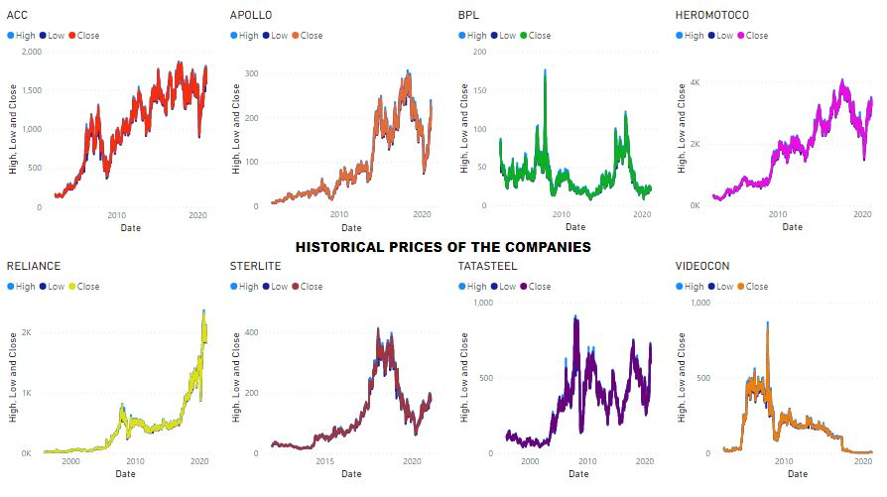
Figure 1
Volume of stocks sold over the years of the eight companies-
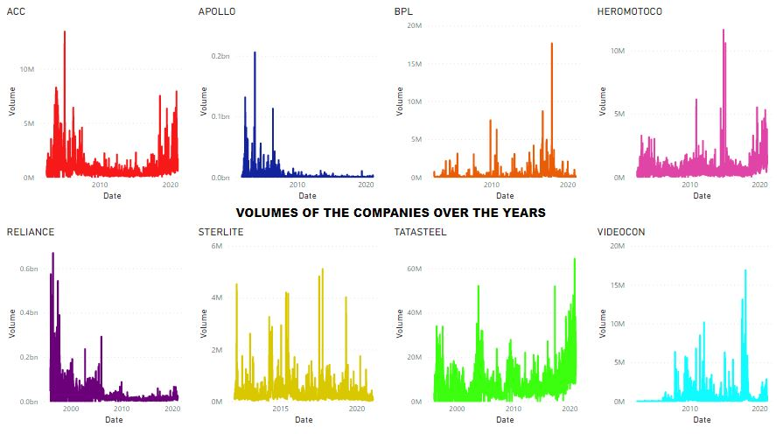
Figure 2
Moving averages of the eight companies for 10, 20, 50, 100 days-

Figure 3
- Finding the average daily return of stock-

Average daily returns histogram plot of Videocon Company-

Figure 4

Average daily returns histogram plot of Tata Company-

Figure 5

Average daily returns histogram plot of Sterlite Company

Figure 6

Average daily returns histogram plot of Reliance Company

Figure 7

Average daily returns histogram plot of Hero Company

Figure 8
Average daily returns histogram plot of Apollo Company

Figure 9

Average daily returns histogram plot of ACC Company

Figure 10

Average daily returns histogram plot of BPL Company-

Figure 11
- Finding the correlation between various stocks' daily returns and closing prices-
Correlation plot between same Company- Apollo

Figure 12
Correlation plot between ACC and Apollo -

Figure 13
Correlation plot between Videocon and Hero

Figure 14
Correlation plot between BPL and Apollo -

Figure 15

Correlation plot between Tata and Sterlite -

Figure 16
Correlation plot between BPL and Hero -

Figure 17
Correlation plot between Reliance and BPL -

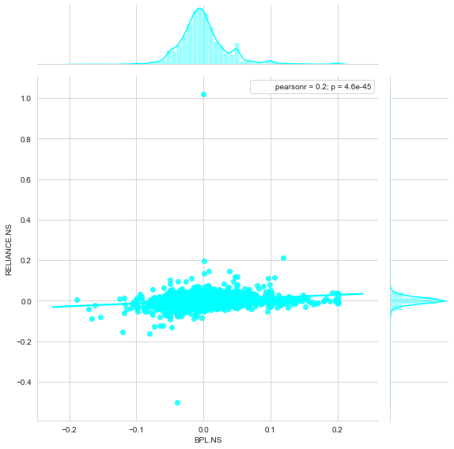
Figure 18
Correlation plot between BPL and Sterlite -

Figure 19
Correlation plot between Hero and Sterlite -

Figure 20
Correlation plot between Reliance and Videocon -

Figure 21
Correlation plot between Reliance and Hero -

Figure 22
Correlation plot between Tata and BPL -

Figure 23
Correlation plot between Hero and Apollo -

Figure 24
Correlation pair plot between all possible combinations of eight companies’ close price

Figure 25
Correlation pair plot between all possible combinations of eight companies’ daily returns
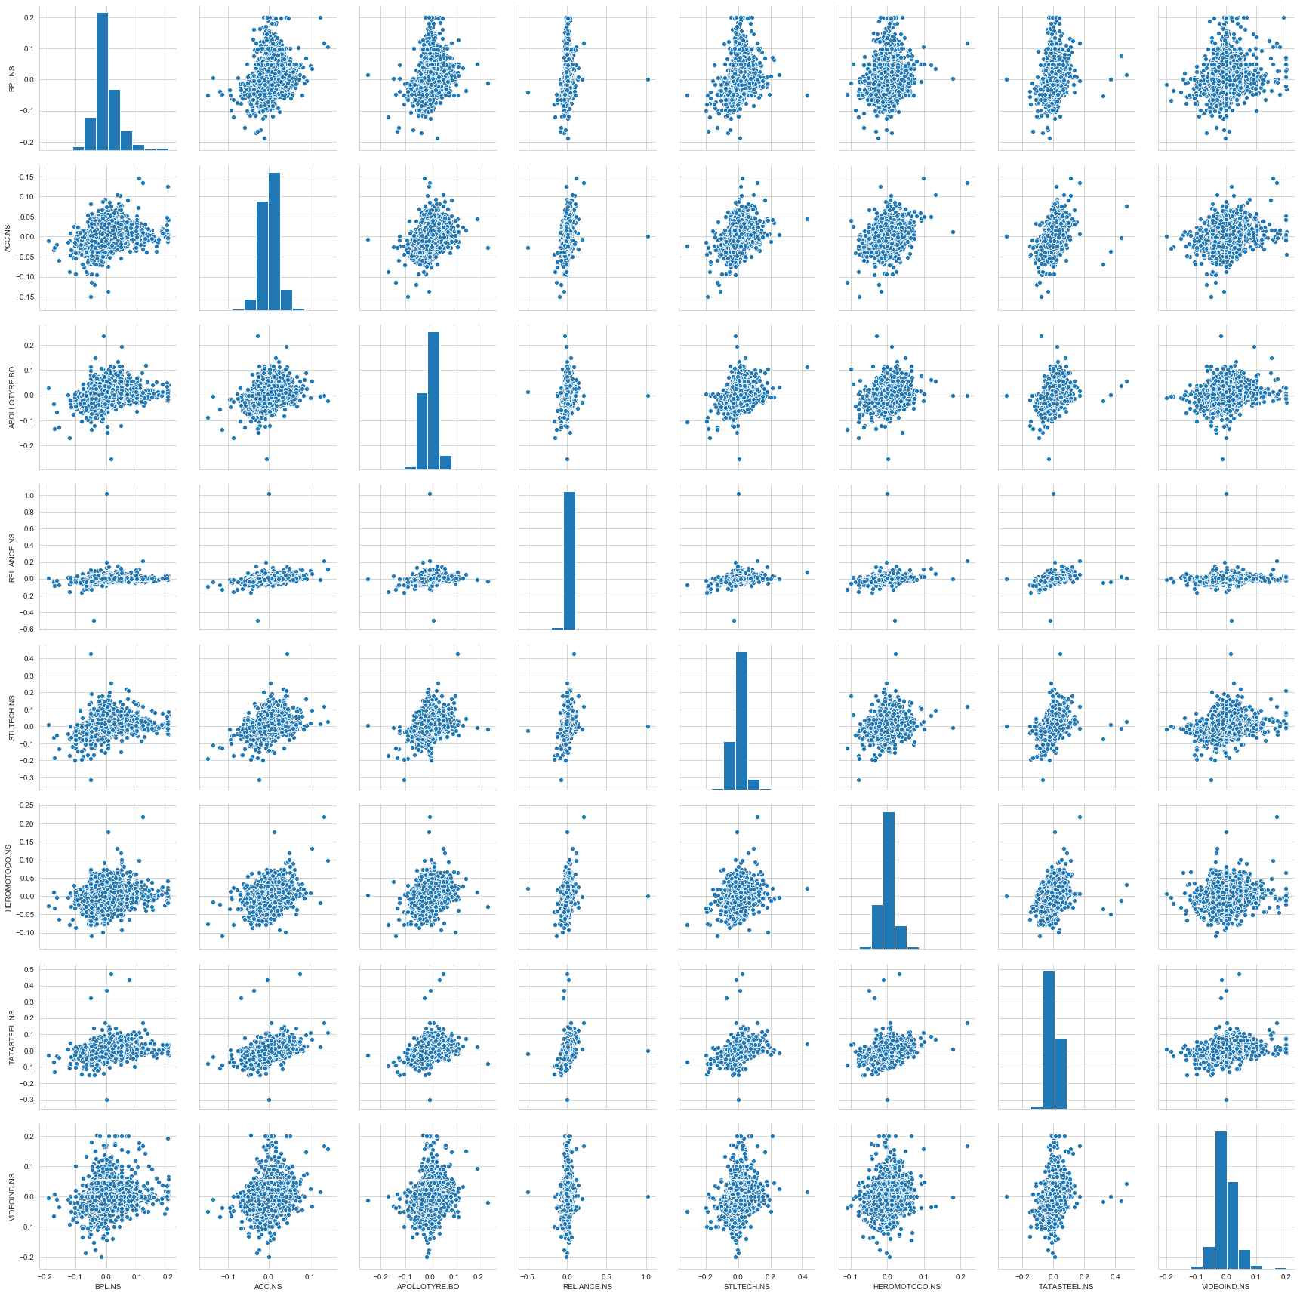
Figure 26
Correlation PairGrid plot between all possible combinations of eight companies’ close price

- RESULTS AND DISCUSSION

- Finding different stocks price change and moving average stock over time-
ACC:
ACC-merge of 10 companies from India’s top 4 business group in 1936 belongs to Tata group. It nearly had 92% of country’s cement marker. Other than cash, ACC had 6, 03, 200 number of equity shares for consideration. In the 50’s, ACC in joined with Vickers Ltd., and Babcock & Wilcox Ltd., forming ACC-Vickers-Babcock Ltd. In the 60’s, ACC made a sale of all immovable properties in Pakistan at a price of 3.26 crores. In the 70’s, two collieries owned by ACC were taken over by our government under the coal Mines Act, 1973. In the 80’s, ACC made its way into chemical engineering as process consultant bringing in 60.01 lakhs. Vickers Ltd., UK disinvestment made the company to ACC-Babcock Ltd. In the 90’s, Tata sold their stake of 14.45% in ACC to Gujarat Ambuja Cement. This made ACC, an oldest company, a part of a family business. ACC managed to maintain their market volume under new owners. In 2005, ACC’s stake in Gujarat Ambuja Cement has been sold to Swiss multinational Holcim that brought a boom in profits of ACC and cement demand in 2005. ACC’s transformation was complete once ACC agreed to pay royalty to Holcim as they were using the technology of it at the rate of 1% of the net sales. In 2020, ACC stock price had a jump over 6% despite its weak numbers during the April-June months. In 2021, so far, ACC had a jump of 7% in its stock price.
Apollo:
Apollo Tyres- established in 1972, a public company promoted by Bharat Steel tubes Ltd., Jacob Thomas, Mathew T. Marattukalam, and Raunaq Internation Private Ltd. The company has established its plants over the country during the 90’s. In 2009, Vredestein Banden B.V, a Netherlands based tyre company was acquired by Apollo tyres. The company cut ties with Dunlop Company in Africa and Sumitomo Rubber Industries, Japan in 2013 followed by starting a global R7D centre in Enschede, Europe of Netherlands. Over the past few years, the company had made plans in setting up various factories in different parts of the country including R&D centres.
BPL:
BPL- British Physical Laboratories established in 1963, a private company that manufactures electronic test and measuring instruments, electro cardio graft patient monitoring systems etc. It is a collaboration with U.K based BPL instruments Ltd. In the 80’s BPL started manufacturing televisions and telecommunications equipment along with many other collaborations from different countries say Japan, US. With economic liberalisation in 1991, the company had to face competition from LG, Samsung companies of South Korea. With internal disputes, external threats were not paid attention leading to loss. A joint venture announcement in 2005 by the company resulted in transferring their colour television business to new venture. Over the past few years, the company has picked up from their loss by entering various domains and partnering with e-commerce sites like Flipkart and Amazon.
Hero motors:
Hero motors- two wheeler manufacturing company established in 1984 as a joint venture between Honda Motors, Japan and Hero Group, India. In the 90’s and 2000’s the company went on releasing latest and commercial two-wheeler models, establishing different branches across the country. In 2010, the company has transferred their shares to HIPL resulting in company being controlled by Munjal Family. According to 2011 share transfer agreement, company agreed to transfer 26% of share to the Indian Promoter group which brought an end to the joint venture. In 2012, the company and Erik Buell Racing (EBR) of USA became strategy partners to launch high-end bikes. The company continued launching new bike models, establishing more plants across the country over the years.
Reliance:
Reliance- Established in 1966, a commercial corporation entering power, petroleum and financial sectors within a short period of time. In the 70’s and 80’s the company has set up plants polyester staple fibre plants, facilities, labs etc. In the 90’s the company has entered telecom industry and collaborated with many others. In 2000’s Reliance has commissioned world’s largest grassroots refinery. In 2005, the company has been split. In 2006, the company has entered the retail industry, followed by profits with 3300 stores in India. In 2008, the company signed several agreements in regards of polyester, petroleum, petrochemical, gas sales etc. At this point many companies have become Reliance’s subsidiaries. In 2009, the company started production of hydrocarbons in Krishna Godavari waters resulting in discovery of gas, oil. In 2010, the company established a photo-voltaic power plant in Delhi. In the same year, the company entered the broadband services sector. In 2011, the company has made an agreement with Bharti Axa Life Insurance, making them own 57% of the shares. In the same year, BP and Reliance formed a 50:50 joint venture. Over the years the company has made many deals resulting in its growth gradually in the market.
Sterlite Technologies:
Sterlite- A digital technology company with offices all over the world is established in 1988. The company has partnered with many industries. Hyper scale network design and deployment, Network software, optical fibre and cables are the company’s specialities. In 2015, the company had made a deal with Elitecore technologies that costs 180 crores. The company’s subsidiary Sterlite Global Venture has made a deal with Metallurgica Bresciana in 2018. The same subsidiary has taken in Impact Data Solutions in 2019. The company has had a stake of 12.8% in Israel based ASOCS in 2020.
Tata Steel:
Tata- Found in 1907 the company deals with tin bars, sleeper bars, hammers, rails, shovels etc. In the 70’s West Bokaro Ltd., subsidiary became a part of the company. In the 80’s an agreement between ACC and Tata Steel has been made. Soon, Tube Company became a part of the company. Company underwent many diversifications and amalgamations over the years. It also received many major projects resulting in profits. In 2000’s the company has setup several plants including jiggling and hydro-cyclone plant, processing units etc. In 2008, the company made a deal with CMI FPE and Tinplate Company and AI Bahja group of Oman. Same year brought many awards to the company making it a familiar name in the country’s households. In 2011, the company made a joint venture contract with automotive cold- rolled flat products. Same year, the company’s share-hold in TCIL spiked to 59.45% from 42.88%. In 2012, the company has expanded aerospace operations in China. Over the years, the company has improved its product quality and bagged many awards for its work.
Videocon:
Videocon- Established in 1986, Videocon is a private company that dealt with paper tube trading in the beginning and later diversifying. After the 1991 economic reforms, the company went through a change of transfers in the equity shares. In 2005, the company acquired the Electrolux India stake, Hyundai Electronics and won right for exploring oil blocks in Nigeria. Over the years, the company has launched products, setup facilities and made agreements with different countries. In 2008, company entered telecom services and brought in major global retails. Over the years the company has come up with several products, changes in the company and many other collaborations.

- Finding the average daily return of stock-
We find the daily returns of the companies’ stocks by using close prices with bin size 100. Using these histograms we calculate the correlation values between companies.
- Finding the correlation between various stocks' daily returns and closing prices-
We calculate the correlation between the companies using pearsonr correlation coefficient. As we see correlation between two same companies is 1 and the graph shows a straight line indicating linear relationship between them. When we calculate ach company correlation with the rest of the companies- we can see that heromotors and Videocon companies have the least correlation between them and Tatasteel and ACC have the maximum correlation. In order to understand the correlation between the companies all at once we used different visual displays such as pairplots, pairgrids etc. We also used heatmaps to find correlation between all the companies’ closing prices and daily returns. We can see that in closing price heatmap, there is negative correlation between few companies say reliance and tata, sterlite and heromotors etc indicating that rise in one of the company’s share price might lead to loss in another company’s share. In case of daily returns we see no negative correlation amongst the companies.
- Finding the amount of risk one can have by investing in a certain stock-
By going with basic risk analysis which is considering mean, standard deviation and quantiles we can see that the companies ACC and Heromotors are the ones that have low risk and positive returns among the eight companies. We can also see the amount at risk that we found using quartiles for example in case of Apollo company when one plans to invest 1000 rupees, maximum loss one can face is 3.730 rupees at 95% confidence. We also calculated risk using Monte-Carlo method for all the eight companies. We can see various companies risk analysis outputs in the above figures. To explain companies in particular-
ACC- with starting price as Rs. 1703.59, when one invests in ACC Company the maximum loss one can face is Rs. 101.49 and as we also calculated the future price, we can see that for the next year, the company can reach a peak of more than Rs. 1800 and low of less than Rs. 1600.
Apollo-with starting price as Rs. 180.25, when one invests in Apollo Company the maximum loss one can face is Rs. 10.59 and as we also calculated the future price, we can see that for the next year, the company can reach a peak of Rs. 190 and low of less than Rs. 170.
BPL- with starting price as Rs. 22.5, when one invests in BPL Company the maximum loss one can face is Rs. 1.32 and as we also calculated the future price, we can see that for the next year, the company can reach a peak of Rs. 24.5 and low of less than Rs. 21.5.
Hero- with starting price as Rs. 3170.5, when one invests in Hero Company the maximum loss one can face is Rs. 184.62 and as we also calculated the future price, we can see that for the next year, the company can reach a peak of above Rs. 3400 and low of less than Rs. 3000.
Reliance- with starting price as Rs. 1994.65, when one invests in Reliance Company the maximum loss one can face is Rs. 116.07 and as we also calculated the future price, we can see that for the next year, the company can reach a peak of more than Rs. 2150 and low of less than Rs. 1850.
Sterlite- with starting price as Rs. 180, when one invests in Sterlite Company the maximum loss one can face is Rs. 10.50 and as we also calculated the future price, we can see that for the next year, the company can reach a peak of Rs. 190 and low of less than Rs. 170.
Tata- with starting price as Rs. 672, when one invests in Tata Company the maximum loss one can face is Rs. 39.35 and as we also calculated the future price, we can see that for the next year, the company can reach a peak of more than Rs. 710 and low of less than Rs. 640.
Videocon- with starting price as Rs. 5.9, when one invests in Videocon Company the maximum loss one can face is Rs. 0.36 and as we also calculated the future price, we can see that for the next year, the company can reach a peak of more than Rs. 6.3 and low of less than Rs. 5.6.
- Predicting the future of stocks’ behavior-
For the prediction purpose we have explained the working of RNN-LSTM followed by the code. Once we run the code, the model starts training showing us the loss after each epoch batch wise. Batch is nothing but dividing the data into batches and then training the model. We can see the predicted stock prices compared with original prices in the above figures. Once the training is done, we test it on the test data and predict the next day price of the company. To explain in particular-
ACC- The predicted price of ACC Company for the next day i.e. on 23/04/21 is Rs. 1824.96.
Apollo- The predicted price of Apollo Company for the next day i.e. on 23/04/21 is Rs. 197.75.
BPL- The predicted price of BPL Company for the next day i.e. on 23/04/21 is Rs. 26.06.
Hero- The predicted price of Hero Company for the next day i.e. on 23/04/21 is Rs. 2959.68.
Reliance- The predicted price of Reliance Company for the next day i.e. on 23/04/21 is Rs. 968.89.
Sterlite- The predicted price of Sterlite Company for the next day i.e. on 23/04/21 is Rs. 144.03.
Tata- The predicted price of Tata Company for the next day i.e. on 23/04/21 is Rs.756.13.
Videocon- The predicted price of Videocon Company for the next day i.e. on 23/04/21 is Rs. 3.86.

- Finding the stock prices impact on economy (GDP)-
As we seen above, the result of correlation between country’s GDP and Sensex Index is 0.4221 i.e. positive meaning with increase in Sensex Index there’s a notable growth in the GDP of our country. Point to be noted here is that when calculating this correlation I’ve removed the India’s GDP growth in 2020 which is at -7.06% due to covid-crisis. If we calculate correlation by taking 2020 GDP growth in to consideration we get a negative correlation of -0.0722 indicating, with increase in Sensex index there’s a fall in country’s GDP.
- LIMITATIONS
If we observe Reliance predicted and original data comparison data, we can see that the model was not able to predict the rise of Reliance stock prices during 2020 which was due to pandemic i.e. covid. We humans itself didn’t see it coming then how can a model built by human can see it coming?
- CONCLUSION
My objective of exploring, learning and deriving insights from very large datasets has been accomplished. The goals that I’ve set- calculating moving averages, visualizing stock price changes over the years, calculating the correlation amongst the companies, analysing risk in investing a company, predicting the future stock price of the companies followed by GDP growth and Sensex index impact on each other- are all achieved by the end of the project. From the above analysis we can say that one can only predict the stock prices at 95-99 percent confidence but never 100% because we never know what kind of external factors might indulge into market and disrupt its nature.

- REFERENCES
- Shah, Dev & Isah, & Zulkernine, Farhana. (2019). “Stock Market Analysis: A Review and Taxonomy of Prediction Techniques”. International Journal of Financial Studies. 7. 26. 10.3390/ijfs7020026.
- B. Uma Devi D & Sundar Dr.P. Alli(2011). “A Study on Stock Market Analysis for Stock Selection – Naïve Investors’ Perspective using Data Mining Technique” . International Journal of Computer Applications. Volume 34– No.3, November 2011.
- Sudheer, V. (2015).”Trading through technical analysis: an empirical study from Indian stock market”. International Journal of Development Research. Vol. 5, Issue, 08, pp. 5410-5416, August, 2015.
- Gavhane, S. “Stock Market Analysis.” International Journal for Research in Applied Science and Engineering Technology 6 (2018): 2343-2346.
- Venkatesh rathod. “Stock market analysis and prediction’ https://github.com/venky14/Stock-Market-Analysis-and-Prediction
- Md Sohel Mahmood “Build a Time Series Machine Learning Model to Predict Stock Price” https://github.com/mdsohelmahmood/stock-price-predict.
- Prin.Dr. Kishorsinh N. Chavda & Tarsariya Mahendra Kumar S. “Analysis of Impact of Gross Domestic Products (GDP) on Stock Market Returns in India.” 2018 IJCRT | Volume 6, Issue 2 April 2018 | ISSN: 2320-2882.
- Sudharshan Reddy & Paramati Rakesh Gupta. “An Empirical Analysis of Stock Market Performance and Economic Growth: Evidence from India International Research”. Journal of Finance and Economics. ISSN 1450-2887 Issue 73 (2011).
- Sathish, M. Thangajesu & Ganesh, Sudha & Sornaganesh, V. (2020). “Impact of Indian Stock Market Due to Crisis in March 2020”. International Journal of Multidisciplinary Educational Research. 6. 128.

- Cohen, Gil. (2011). Stock Market Analysis in Practice: Is It Technical or Fundamental. Journal of Applied Finance and Banking.
- Manoj Singh. (2021). How to become your own stock analyst
- Adam Hayes. (2021). How does the stock market work?
- Financialexpress.com. Stock and company impact analysis.
- Shah, D.; Isah, H.; Zulkernine, F. Stock Market Analysis: A Review and Taxonomy of Prediction Techniques. Int. J. Financial Stud. 2019, 7, 26. https://doi.org/10.3390/ijfs7020026
- Kamath, Sachin, "STOCK MARKET ANALYSIS" (2012). Master's Projects. 326. DOI:https://doi.org/10.31979/etd.w9nk-m4ut https://scholarworks.sjsu.edu/etd_projects/326

